This is a plugin for Fiji that integrates all the parts of the workflow from raw CT data to the segmentation of the airways, and finally the cross-sectional analysis of airway luminal walls of the different branches. This is more meant to be a how-to guide to go from square 0 to step 9001 so it won’t contain too much overview components. Please read the overview document to see all the exciting features that have been integrated!

General Workflow: CT -> (optional) Binarized & inverted -> Segmentation Mask -> Centerline Skeleton -> Cross-sectional analysis

Many steps are precursors to later stages of the workflow, and therefore may have references to them. It is preferable to read through the manual first or, at least, entire steps at a time.

Contents

Initialization 2

Main UI Overview 3

Step 0.0: Core Segmentation 4

Step 0.1: Thresholding 4

Step 0.2: Automated Segmentation 5

Step 1: Edit Mask 7

Step 2: Skeletonization 11

3D UI 12

Step 3: editing the skeleton 13

5: Edit Skeleton 13

Step 4: Branch Labeling 14

Step 5:Branch/path selection 16

# Initialization

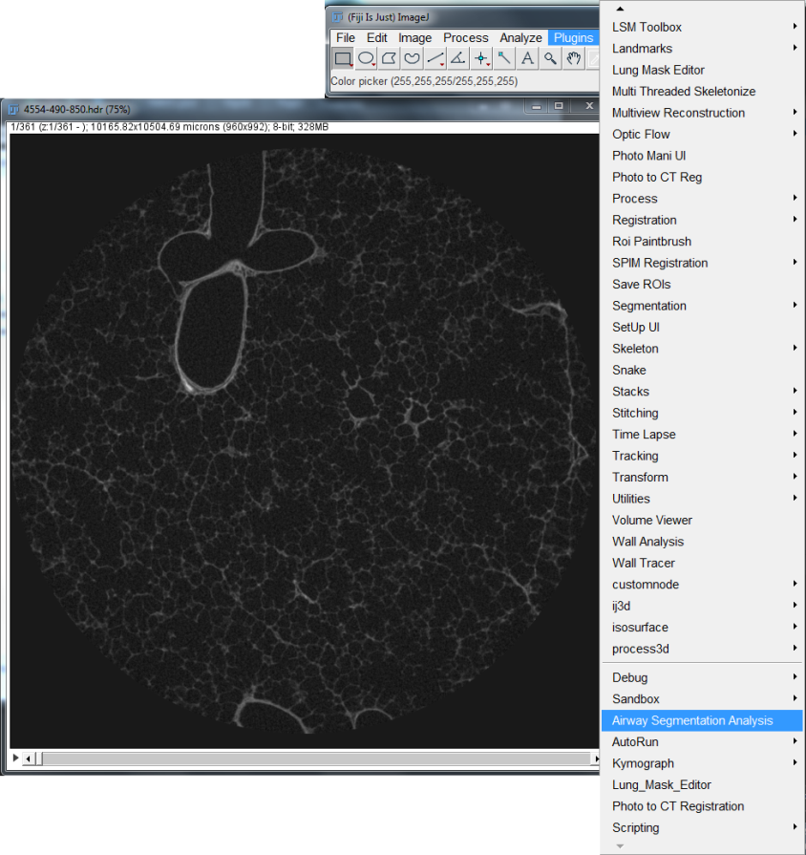

Start by selecting ASA on the Plugins bar in ImageJ

User may load both the existing segmentations and its centerline skeleton if they’re available. Otherwise, the segmentation and its centerline skeleton can be created within the plugin.

A base image must be loaded.

Select an appropriate window size and press “Finalize” to begin.

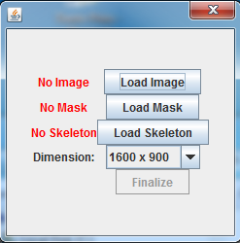

If there is an existing segmentation mask, skip to step 1; if there is an existing centerline skeleton, skip to step 3.

A skeleton can be loaded without its segmentation mask.

# Main UI Overview

Main UI

This invocates of Fiji’s Skeletonize 3D plugin on the segmented mask to generate the segmentation’s centerline for cross-sectional analysis.

Manual tools of creating and editing the segmentation: functions such as replace, append, and subtract; and interpolation versions. Also included is an ROI paint brush tool and undo/redo buffer.

Preprocessing of the CT image with the ultimate goal of creating a binary version with a threshold in order to run automatic segmentation algorithm; it’s non-essential to the overall process.

Orthogonal planes of the CT image.

Main view of the CT Image; used to perform segmentation of structures for analysis.

2

1

3

4

5

6

7

Segmentation of the core to exclude the background and calculate segmented volume. This is a non-essential step. Only the processed image will be segmented.

4

3

1

2

5

Control panel for the automatic segmentation algorithm that discovers and segments tubular structures, and in the case of airway segmentation, detection and exclusion of alveolar space. Results may vary; requires the “Processed” Image to be binary.

6

7

# Step 0.0: Core Segmentation

(OPTIONAL) Step 0.0: Core Segmentation

# Step 0.1: Thresholding

In order to crop out the background of the dataset, start by toggling on “Do Core Segmentation”. While this mode is enabled, any ROI drawn throughout the slices will be saved for interpolation purposes. Draw ROIs at the desired starting slice and at the ending slice to be cropped. Additional ROIs can be drawn throughout the desired range of slices to explicitly state the region to crop.

After the ROIs are set, hit “Segment Core” to interpolate between all the ROIs drawn and crop out anything that isn’t in the range of and outside of the resultant ROIs. A log message will appear to report the volume of the cropped regions.

Note: Cropping is only visualized on the “working copy” of the dataset. Use “Toggle Processed” to toggle between it and the original image.

(OPTIONAL) Step 0.1: Process working copy

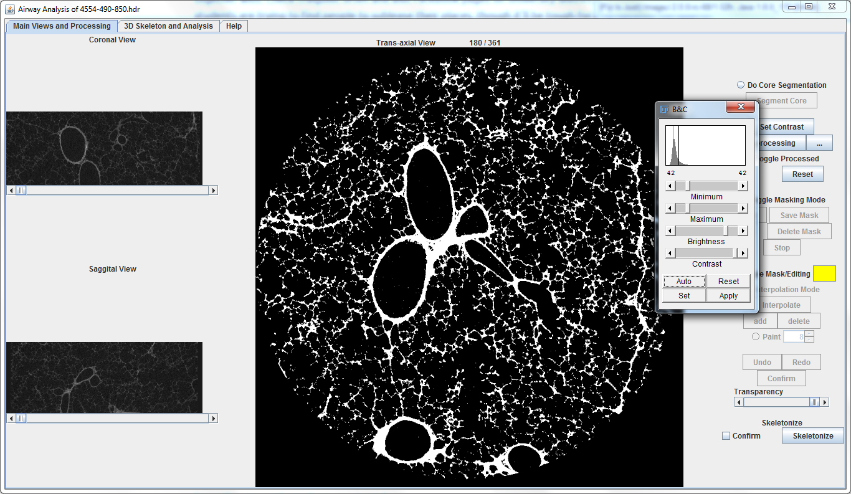

First select “toggle processed” to bring up the working copy of the original data set.

Then use the “Set Contrast” button to bring up the “Brightness and Contrast” plugin to threshold the image. Threshold values should binarize the image as much as much as possible; ideally with minimal noise within the lumens of the structure that will be segmented while still maintain as much structural integrity as possible. Threshold values vary by dataset, use your best judgement. Hit apply to apply the threshold onto the image.

If further image processing is required with other plugins, create/edit the macro file using the “…” button to create the macro file for image processing and populate the file with commands to be applied to the image. After the macro file is *saved* and *closed*, use the “PreProcessing” button to apply the macro and save the processed image. (suffix “.Edit”) (at the very least, the macro file should consist of the following command: “run("Make Binary", "method=Default background=Default");”)

If needed, use the “Reset” button with the confirmation checkbox to its left selected to reset the working image back to the original to start over again.

Note: This step is not necessary if you already have an existing segmentation of the airways or you wish to manually segment the airway. The act of creating a binary image is just to run the automatic seed-point based airway segmentation function.

# Step 0.2: Automated Segmentation

(OPTIONAL) Step 0.2: Set Seed Points for Auto-Segmentation

**Processed image should have *Tissues* at pixel brightness 255 and *Air* at pixel brightness 0 regardless of LUT.**

Select “Toggle Masking Mode” to enable the controls for the automatic segmentation.

On a starting slice, use the ImageJ’s “point” tool to set 1 or multiple points in lumens of the structure that need to be segmented.(Note: Ensure the initial seed points are in a good region without any leakages. (test for leakage by using the wand tool to make a selection) Manually repair leakages by using the paint/pencil tool in ImageJ with the colour set to the same colour as the tissue).

Once the seed points are set, use “Add” to begin the process which will bring up the range selection for the slices the algorithm should stop at. Default values will allow it to go through all the slices. Setting an appropriate range is non-essential but will help the algorithm stop at an appropriate slice.

Finally, Press “Start” to begin the process.

Note: During the process, the “Stop” button will be enabled allowing immediate returns of finished segmentations. It should be used if it is sensed that the algorithm has failed to stop at the appropriate point. The process is bi-directional; pressing “Stop” will only stop it in the direction it’s currently going, press “Stop” again exit the other direction.

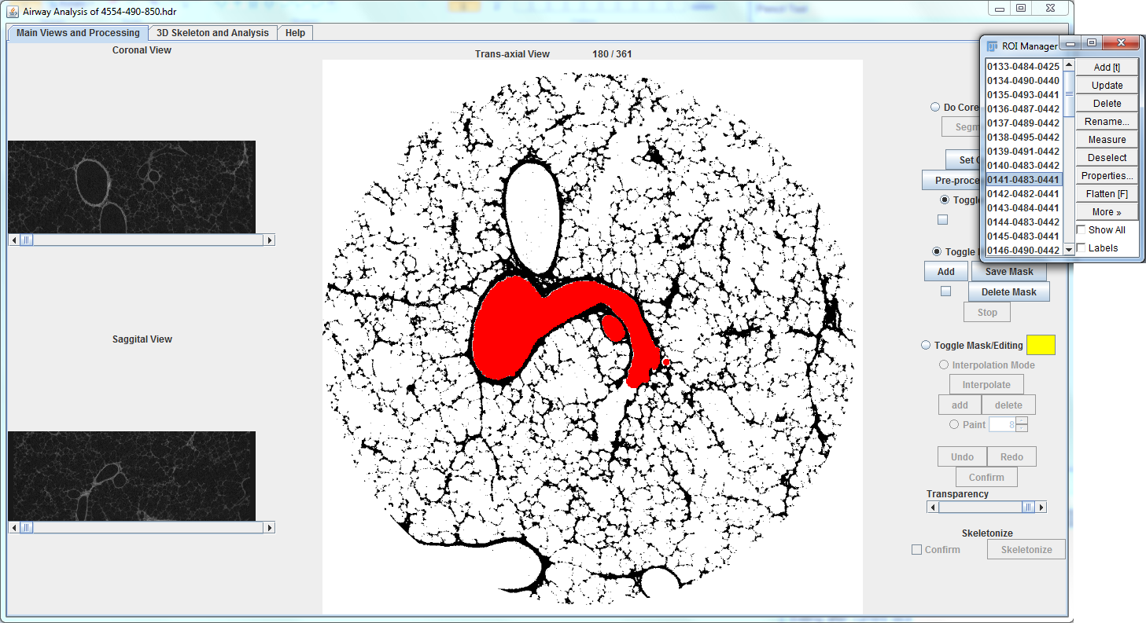

The runtime results (whether it was stopped with user intervention or on its own) will appear in an ROI manager. Any undesirable selections can be discarded here by removing it from the ROI manager. Edits can be made here by editing and updating the respective ROIs in the ROI manager or in step 1.

To confirm and append these resultant segmentations to the overall segmentation, press “Save Mask”. This will close the ROI manager and append all of its contents to the final segmentation and save the mask as an analyzed file. (suffix .Mask)

This step can be rerun as many times as it takes to generate more segmentation. Steps for manual segmentation and the editing of existing segmentation will be explained below.

Note: In order to reduce runtime, the segmentation algorithm will stop at any regions that are already part of the existing segmentation.

Note: the usage of the automatic segmentation algorithm is non-essential. Segmentations can be created in any way (ie. manually, with another plugin in ImageJ, with a third-party software, etc.).

Note: Algorithm does its best, desirable results not guaranteed.

# Step 1: Edit Mask

Step 1: Manual Segmentation Creation/Editing

Draw a ROI to replace the existing mask on the current slice.

Select “Toggle Mask/Editing” to enable the visualization of the segmentation mask and to perform editing. The following list different edits that can be done.

Replacing

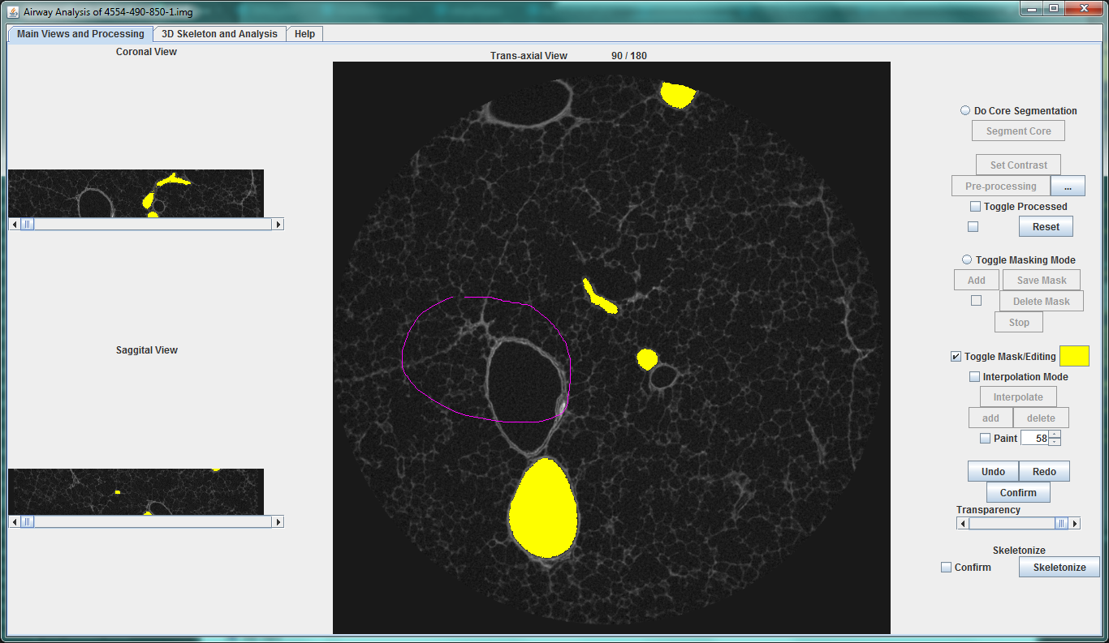

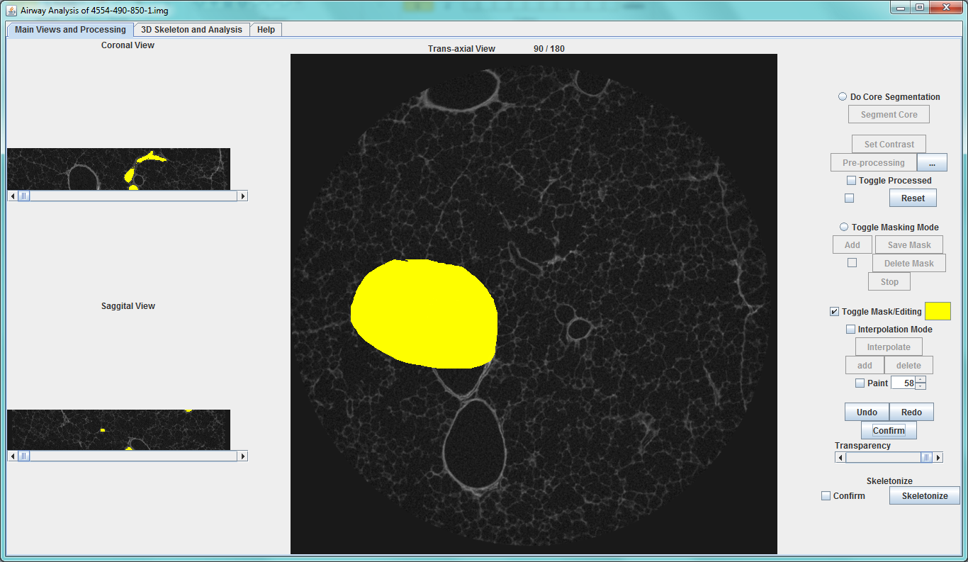

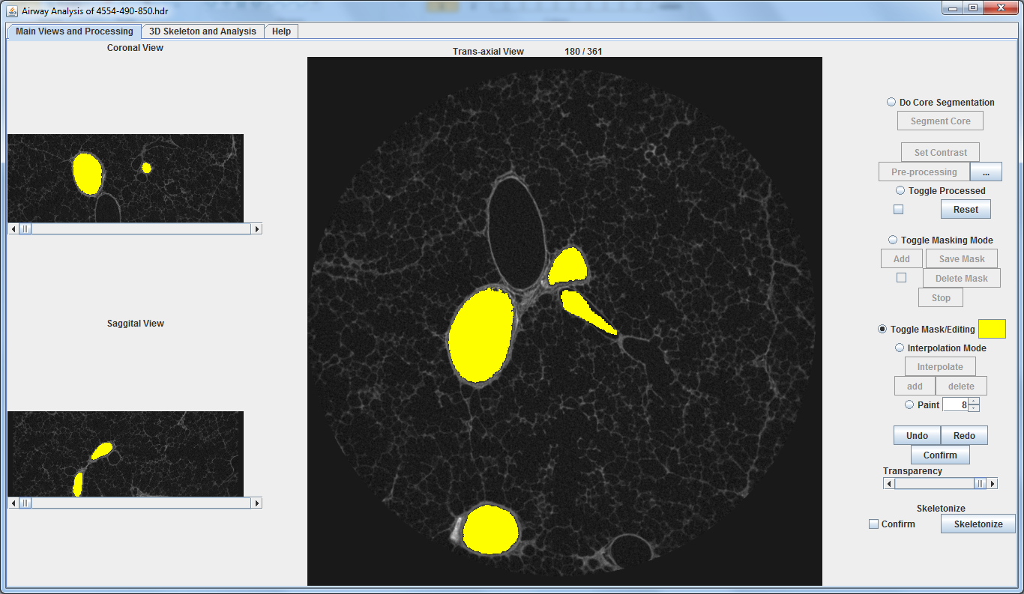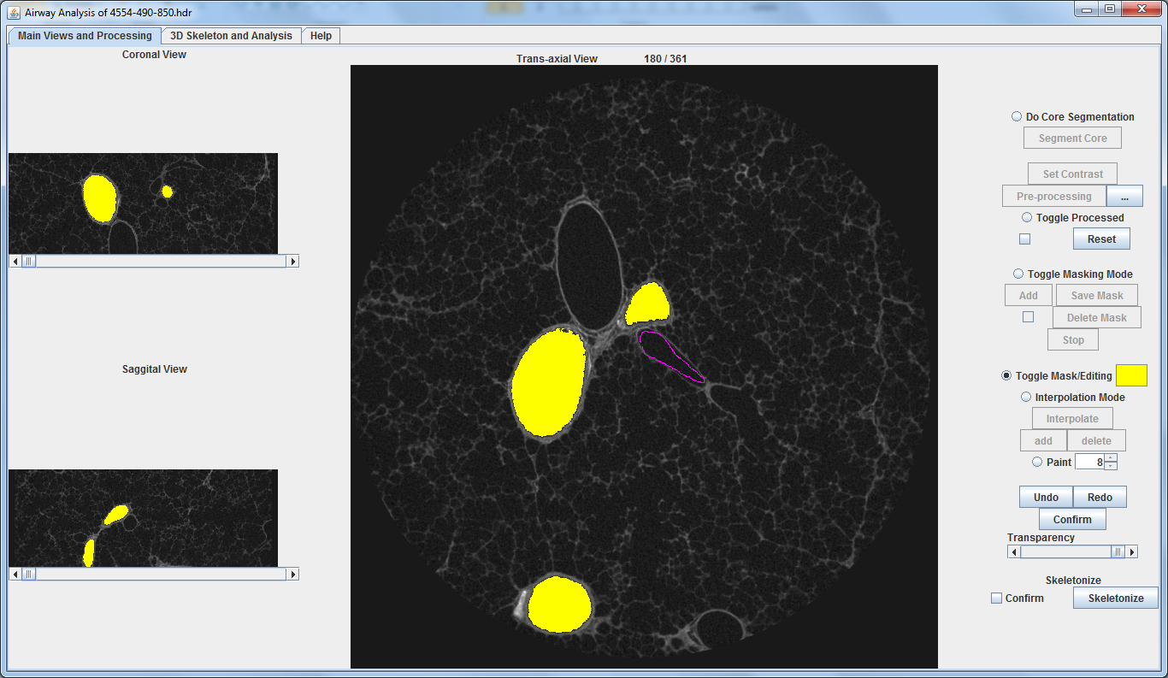

Hold Shift while drawing a ROI to append to the existing mask

Appending

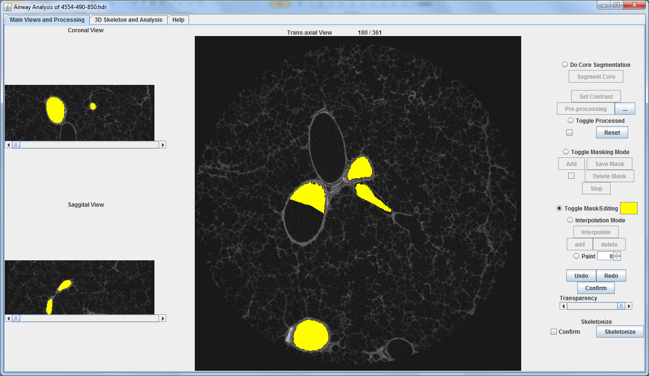

Hold Alt while drawing an ROI to subtract from the existing mask

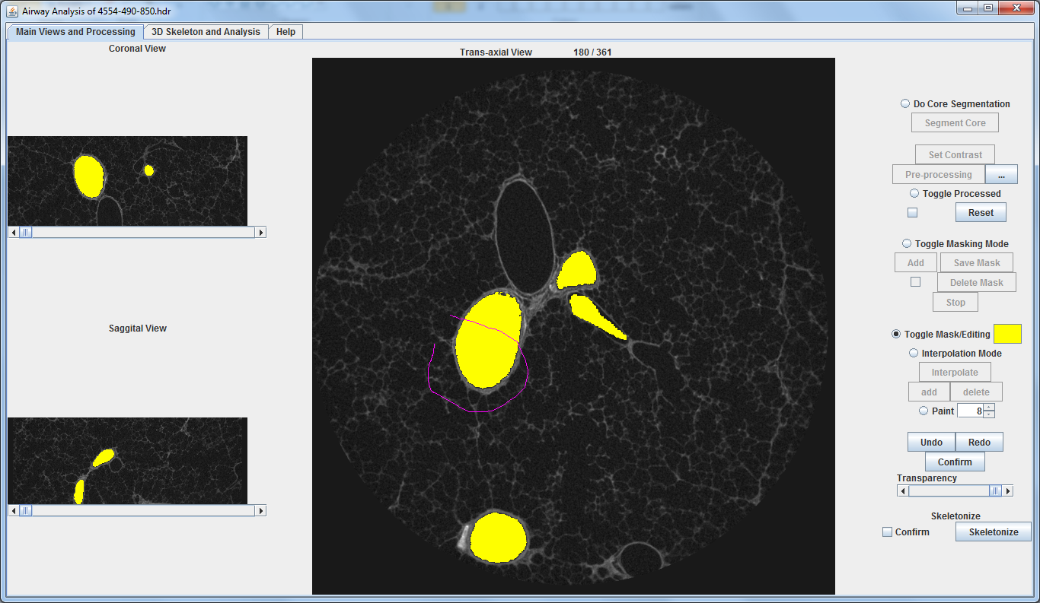

Subtracting

Hold Alt while drawing a ROI to subtract from the existing mask

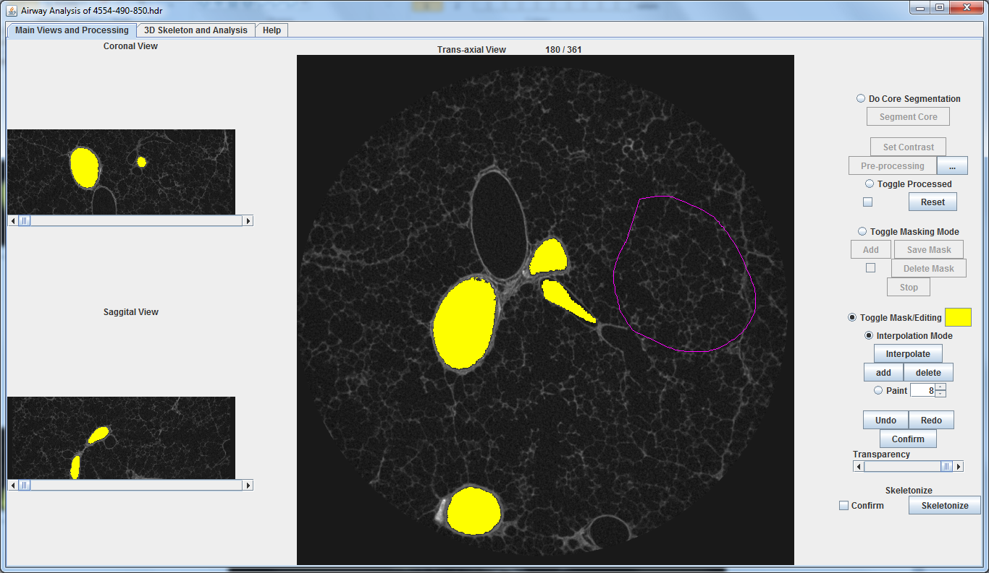

Interpolation

Select “Interpolation Mode” to toggle on interpolation mode

While in interpolation mode:

* Any ROI drawn will be kept track independently from the existing segmentations.
* After several ROIs are set throughout different slices, click *INTERPOLATE* to create ROIs between all the ROIs that were set.
* Click *ADD* to append all the temporary interpolated and drawn ROIs to the overall segmentation.
* Click *SUBTRACT* to subtract from interpolated regions.

Interpolation mode is useful for the creation of structural masking through many slices without having to draw the ROI on each slice.

Toggle on and off interpolation mode to reset.

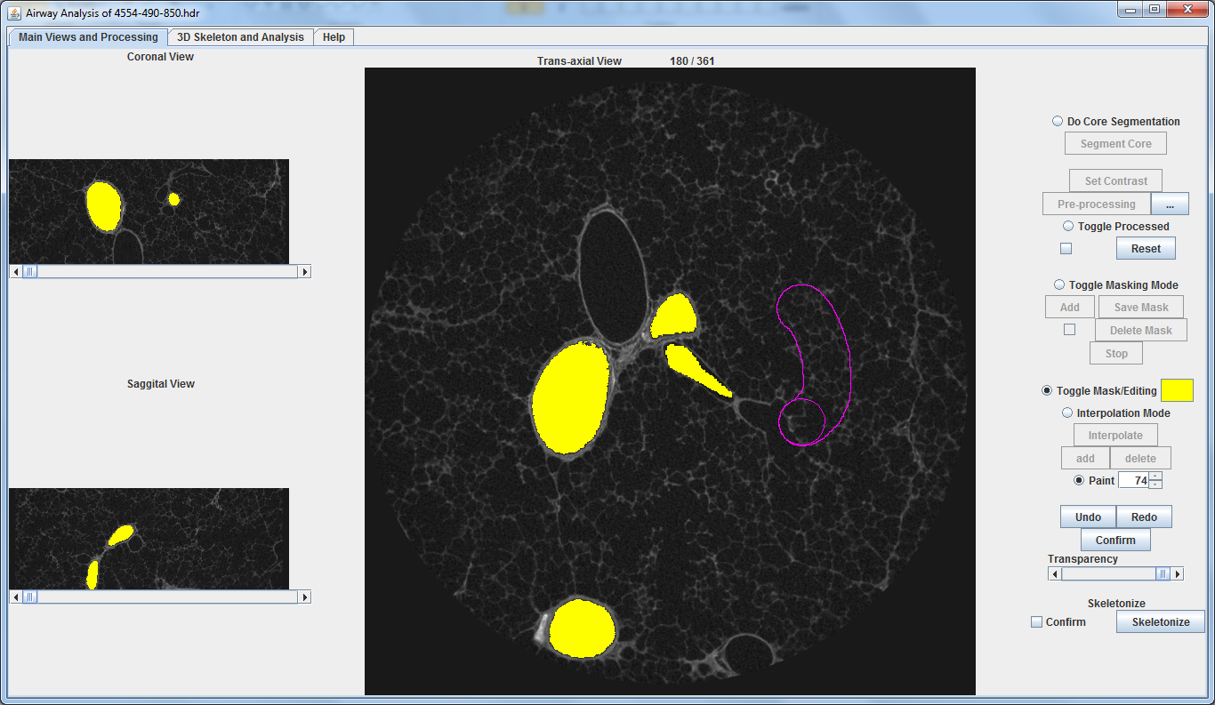

ROI Paintbrush

Select “Paint” to toggle on paintbrush mode; use the number spinner next to it to change the size.

While in paintbrush mode:

* An overlay will follow the cursor to represent the paintbrush size.
* Press and hold left click while dragging to paint an ROI.
  + By default, the painted regions will be appended to the segmentation. If ALT was held it will subtract instead.
* Creates interpolation ROI when used in conjunction with interpolation mode.

Undo, Redo, and Confirm

Any edits made to the segmentation mask are appended to the undo buffer. Use the Undo and Redo button to go between edits. “Confirm” will save the current segmentations into an analyze file and clear the undo buffer. (suffix “.Mask”)

# Step 2: Skeletonization

Step 2: Skeletonize (Find Centerline Skeleton of the Mask)

Once the segmentation has been created and edited, and finalized with the “Confirm” button, select the check box to its left and press “Skeletonize” to calculate the segmentation’s centerline skeleton and saved. (suffix, “.Skeleton) This uses the same “Skeletonize (2D/3D)” plugin bundled with Fiji.

**This concludes the 2D portion of this plugin. The rest will be done at the next tab in 3D view.**

# 3D UI

3D Rendering

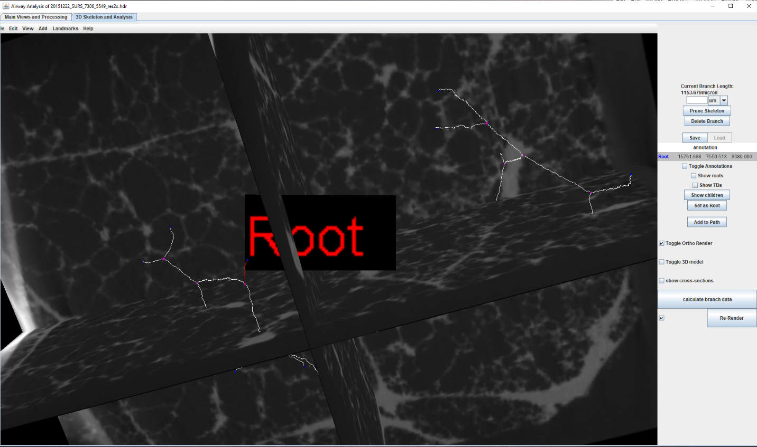

Toggles for the visibility of the 3D render of the CT scan and the airway mask along with representations of the cross-sections in 3D. The centerline skeleton, if present, will always be visible.

4

3

2

1

2

1

Skeleton Editing options: prune all leaf branches under a certain length and manual branch deletion. Displays the length of currently selected branch as a guide to what length of branches should be pruned.

6

5

4

Labeling of the centerline skeleton’s different branches.

All labeling can be saved and loaded in future sessions. Press “Save” to save all the annotations and other information and “Load” to load a previously saved session.

Creates a csv file with data on branches including length, geometric measurements and generational information.

5

6

Generate the 3D viewer and render/re-render the components. The checkbox to the right must be selected as a “confirmation”.

Plugin starts without the 3D viewer being initialized.

3

Toggle annotations shows all annotations, roots shows branches with ‘Root’ in the name and TBs with ‘TB’ in the name

Show children will display branches that are children of the selected branch in green

Add to path bring up the cross section analysis menu.

“Set as Root” will set currently selected branch as the root of its tree and automatically label its branches. It will also allow path analysis from root to a branch within its tree.

In the 3D viewer you can see different types of branches in different colours. The selected branch will be red. When you click show children, all branches in green along with the selected branch will have their generational children turned green, so one can traverse down the airway. Green branches can be reset by hitting the toggling annotations. When a branch is added to the segmentation it will turn purple and a branch on the segmentation while selected will be pink. The position of the ortho render can be changed by right clicking it and hitting adjust slices.

Step 3: Editing the Skeleton

# Step 3: editing the skeleton

# 5: Edit Skeleton

Selecting a branch will display it length. This can be used as a guide to determine what length of branches should be pruned while longer branches will remain. Enter the desired length to prune and select “prune skeleton”. The Pruned version will be saved as a separate file in the same folder as the CT image. (suffix “.pruned”)

Often times, the initial skeletonization of the airway mask will produce many false edges. It is essential to prune away all the false edges in order to continue with branch analysis.

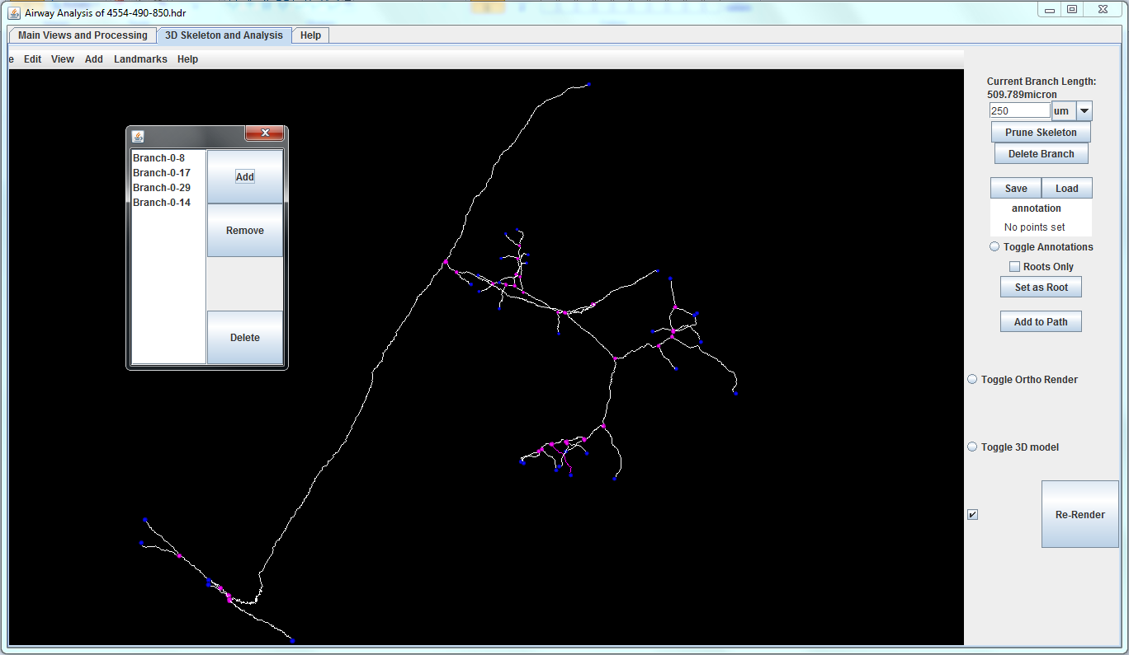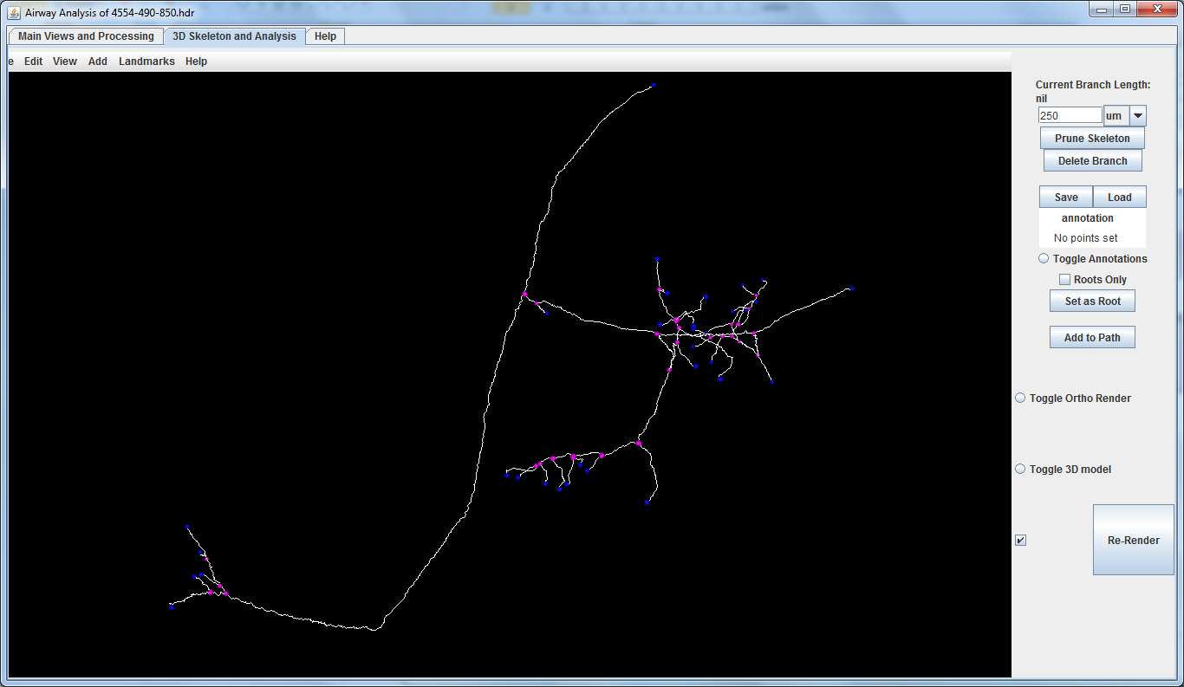

Branches can also be manually deleted by selecting “Delete Branch” which will open this UI box to be filled with all the branches to be deleted to be done at once.

All leaf branches under the length have now been deleted and the skeleton is reformed. This process may be done as many times as necessary.

# Step 4: Branch Labeling

Step 4: Branch Labeling

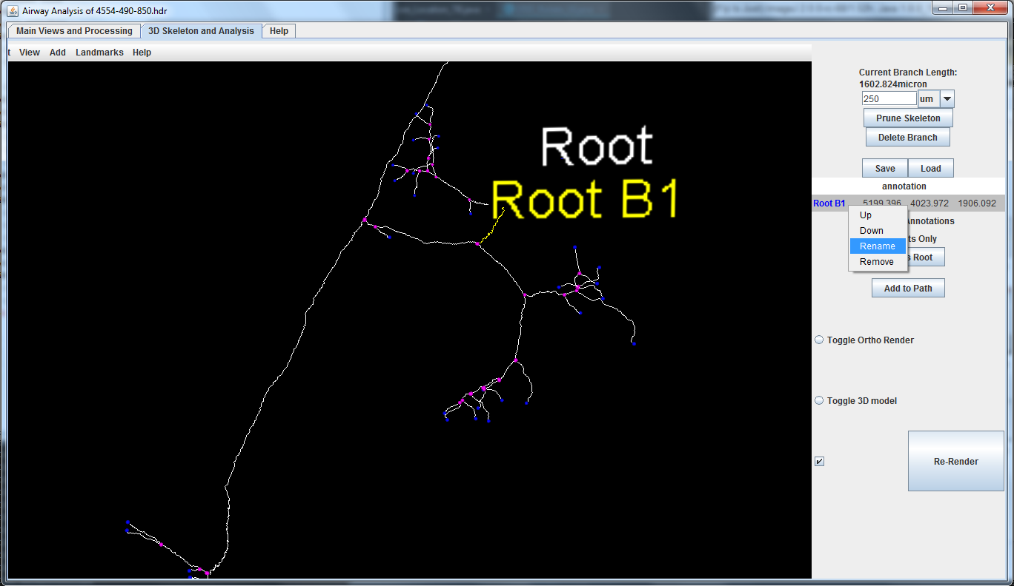

Select a branch while having the “point” tool in ImageJ selected to label it by adding an annotation.

Root can be set by first selecting a branch that has been annotated, then use the “Set as Root” button to set that branch as the root of its tree; doing this will also automatically label all connected branches based on their generation (in the background as default names). If there was a mistake in selecting which branch is the root of its tree, simply re-select another branch and click “Set as Root” again. The new branch will replace the old as the root and the entire tree will be relabeled.

The first annotation on a branch will be saved as its “branch name”, and subsequent annotations will be saved as “comments” (in the excel output). Annotations of a branch can be edited by selecting the branch, then right click on the annotation on the panel on the right to “rename”. If a branch has no annotations, it will carry a default name in the excel table.

# Step 5:Branch/path selection

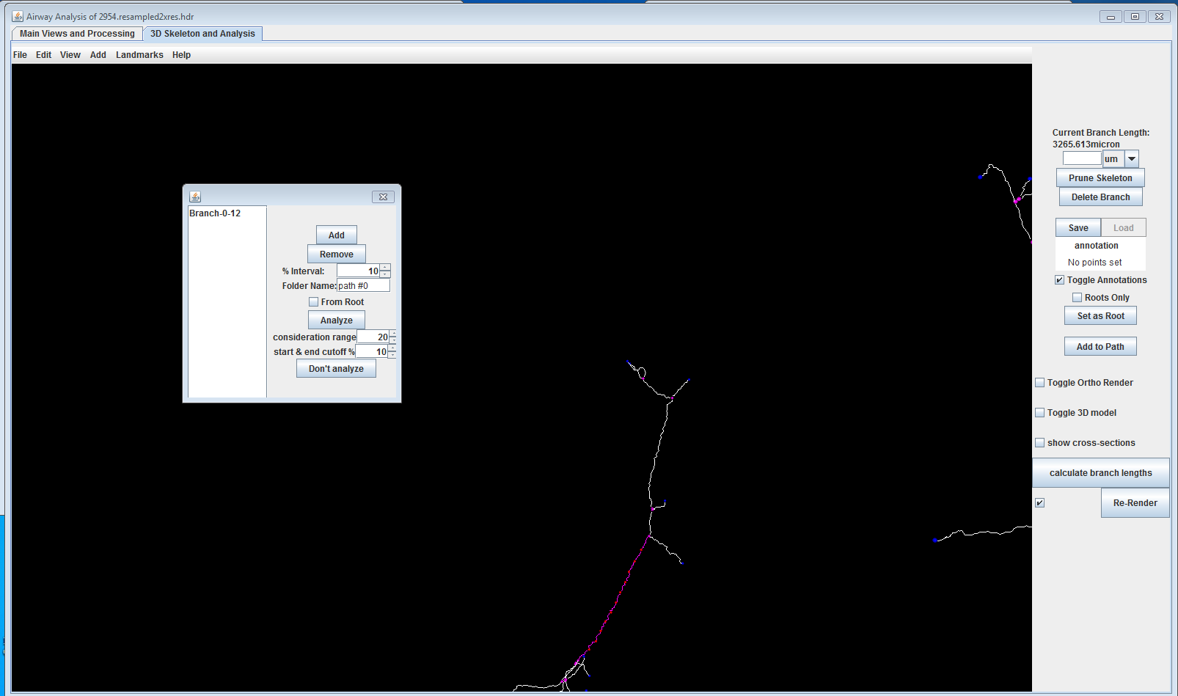

Step 5: Branch/Path Selection

Select “Add to Path” to begin specifying branch(es) to analyze. If there is only one branch selected and the root of its tree is set, the checkbox “From Root” will be available to be selected. This will analyze all the branches from the root to the selected branch as a “path”. Otherwise, single or multiple branches can be added to the list, and they will be analyzed at the same time.

start and end cutoff %: what percentage of the start and end of the branch to ignore

% interval: percentage of the branch to traverse before taking another cross-section

Folder name: the name of the folder measurements and images will be saved.

Consideration range: amount of voxels used to calculate normal plane, more is smoother, less is rougher.

Press “Analyze” to begin and a new UI will appear after the cross-sectional images have been generated.

“don’t analyze” will generate the same cross sections with no procedural inner and outer lumen line generation, useful to quickly see cross sections.

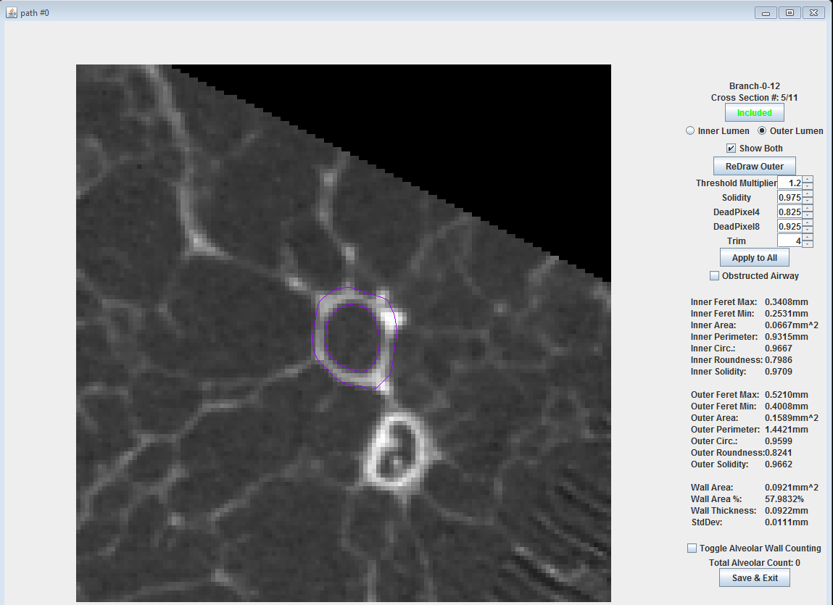

2

3

1

6

5

4

2

Cross-sectional Image Analysis UI

# cross-section images

1

Toggle whether or not this cross-sectional image is to be excluded from the measurement output.

To contradict the program’s judgement on obstructions, click the box and it will regenerate the lumen

Airway wall segmentation editing and visualization.

Select inner or outer to display and allow editing of the respective segmentation.

Selecting “Show both” will display both segmentations but disable manual editing.

Selecting “Redraw Outer” will rerun the automatic segmentation algorithm using the existing inner segmentation; or generate a new inner segmentation if none exists.

Number spinners can be used to adjust threshold values.

3

6

Saves the cross-sectional images and automatically output an excel table of all the different measurements.

The status of the skeleton and branch information (annotations, roots, etc.) will also be saved, and can be loaded up in future sessions.

4

Measurements.

5

Toggle on and off alveolar wall counting mode.

When toggled on, click on the image to add to count, alt-click to delete the last-added count. Counts are displayed by green pixels.

The inner and the outer ROI of the airway wall can be edited by using standard ROI tools in ImageJ while having their respective “Toggles” selected.

For automated edits, any adjustments to the parameters with the number spinner will redraw the outer selection using the new parameters, or press “Redraw Outer” to use existing parameters.

Measurements are updated in real time whenever an edit is made. In addition, make sure to scroll through all the images before saving in order to save all the measurements. (Data considered invalid until it was checked by a user)

When a branch has been analyzed, the location of the cross-sectional images will appear on the 3D rendering as red dots. The number of dots present/image generated is depended upon the percentage interval set when setting up the branch for analysis. Cross sections can also be viewed to determine correctness of the direction used for cross-sectional images.

